**POKEMON INFORMATION**

Description:

There is a list of characters in the [*Pokémon*](https://en.wikipedia.org/wiki/Pok%C3%A9mon) franchise, including the [games](https://en.wikipedia.org/wiki/Pok%C3%A9mon_(video_game_series)), [anime series](https://en.wikipedia.org/wiki/Pok%C3%A9mon_(anime)) and [manga series](https://en.wikipedia.org/wiki/List_of_Pok%C3%A9mon_manga). A single character may appear in multiple continuities, sometimes in the same basic role (e.g. [Giovanni](https://en.wikipedia.org/wiki/Giovanni_(Pok%C3%A9mon))) and sometimes in very different roles (e.g. [Brock](https://en.wikipedia.org/wiki/Brock_(Pok%C3%A9mon))).

Webpage Summary:

It is a Static Single web page displays an different characters of pokemon. If we enter an id in the text field it displays an pokemon character with an image, height and weight of that character. For an effective and convenient for users it was coded in HTML5, CSS and JAVASCRIPT. BOOTSTRAP is used in this web page for interactive and responsive layout. For the user reference, here enables a google link of searching a character of pokemon. Data sets are taken from the public Api’s for importing in the website. SVG file format is used for the background image.This Webpage was launched in S3 in Amazon Web Services.

API USED: **POKEAPI**

PokéAPI is free and open to use. It is also very popular. Because of this, we ask every developer to abide by our fair use policy. People not complying with the fair use policy will have their IP address permanently banned.PokéAPI is primarily an educational tool, and we will not tolerate denial of service attacks preventing people from learning.

Language used: HTML5, CSS, JAVASCRIPT

Framework**:** BOOTSTARP

**Github link :**

<https://github.com/mohammedshajith/mohammedshajith>

**AWS link:**

<http://www.pokemonr2.com.s3-website-us-east-1.amazonaws.com/>

Sample Coding:

<!DOCTYPE html>

<html lang="en">

<head>

<title>Bootstrap Example</title>

<meta charset="UTP-8" />

<meta name="viewport" content="width=device-width, initial-scale=1.0" />

<meta http-equiv="X-UA-Compatible" content="ie-edge" />

<link

rel="stylesheet"

href="https://cdnjs.cloudflare.com/ajax/libs/meyer-reset/2.0/reset.min.css"

/>

<link rel="stylesheet" href="style.css" />

<meta charset="utf-8">

<meta name="viewport" content="width=device-width, initial-scale=1"><link rel="stylesheet" href="https://maxcdn.bootstrapcdn.com/bootstrap/3.4.1/css/bootstrap.min.css">

<script src="https://ajax.googleapis.com/ajax/libs/jquery/3.5.1/jquery.min.js"></script>

<script src="https://maxcdn.bootstrapcdn.com/bootstrap/3.4.1/js/bootstrap.min.js"></script>

<style>

body {

font-family: Arial, Helvetica, sans-serif;

margin: 0;

}

.header {

padding: 40px;

height: 200px;

text-align: center;

background: #ff8000;

color:black;

font-size: 20px;

font-family: "Comic Sans MS", cursive, sans-serif;;

font-weight: bold;

}

.content {padding:20px;}

.button {

background-color:#FA8072;

border: none;

color: black;

padding: 15px 32px;

text-align: center;

text-decoration: none;

display: inline-block;

font-size: 16px;

margin: 4px 2px;

cursor: pointer;

}

body{

background-color: #ADD8E6;

background-image: url("data:image/svg+xml,%3Csvg xmlns='http://www.w3.org/2000/svg' viewBox='0 0 2000 1500'%3E%3Cdefs%3E%3Crect stroke='%23ffffff' stroke-width='.5' width='1' height='1' id='s'/%3E%3Cpattern id='a' width='3' height='3' patternUnits='userSpaceOnUse' patternTransform='scale(50) translate(-980 -735)'%3E%3Cuse fill='%23fafafa' href='%23s' y='2'/%3E%3Cuse fill='%23fafafa' href='%23s' x='1' y='2'/%3E%3Cuse fill='%23f5f5f5' href='%23s' x='2' y='2'/%3E%3Cuse fill='%23f5f5f5' href='%23s'/%3E%3Cuse fill='%23f0f0f0' href='%23s' x='2'/%3E%3Cuse fill='%23f0f0f0' href='%23s' x='1' y='1'/%3E%3C/pattern%3E%3Cpattern id='b' width='7' height='11' patternUnits='userSpaceOnUse' patternTransform='scale(50) translate(-980 -735)'%3E%3Cg fill='%23ebebeb'%3E%3Cuse href='%23s'/%3E%3Cuse href='%23s' y='5' /%3E%3Cuse href='%23s' x='1' y='10'/%3E%3Cuse href='%23s' x='2' y='1'/%3E%3Cuse href='%23s' x='2' y='4'/%3E%3Cuse href='%23s' x='3' y='8'/%3E%3Cuse href='%23s' x='4' y='3'/%3E%3Cuse href='%23s' x='4' y='7'/%3E%3Cuse href='%23s' x='5' y='2'/%3E%3Cuse href='%23s' x='5' y='6'/%3E%3Cuse href='%23s' x='6' y='9'/%3E%3C/g%3E%3C/pattern%3E%3Cpattern id='h' width='5' height='13' patternUnits='userSpaceOnUse' patternTransform='scale(50) translate(-980 -735)'%3E%3Cg fill='%23ebebeb'%3E%3Cuse href='%23s' y='5'/%3E%3Cuse href='%23s' y='8'/%3E%3Cuse href='%23s' x='1' y='1'/%3E%3Cuse href='%23s' x='1' y='9'/%3E%3Cuse href='%23s' x='1' y='12'/%3E%3Cuse href='%23s' x='2'/%3E%3Cuse href='%23s' x='2' y='4'/%3E%3Cuse href='%23s' x='3' y='2'/%3E%3Cuse href='%23s' x='3' y='6'/%3E%3Cuse href='%23s' x='3' y='11'/%3E%3Cuse href='%23s' x='4' y='3'/%3E%3Cuse href='%23s' x='4' y='7'/%3E%3Cuse href='%23s' x='4' y='10'/%3E%3C/g%3E%3C/pattern%3E%3Cpattern id='c' width='17' height='13' patternUnits='userSpaceOnUse' patternTransform='scale(50) translate(-980 -735)'%3E%3Cg fill='%23e5e5e5'%3E%3Cuse href='%23s' y='11'/%3E%3Cuse href='%23s' x='2' y='9'/%3E%3Cuse href='%23s' x='5' y='12'/%3E%3Cuse href='%23s' x='9' y='4'/%3E%3Cuse href='%23s' x='12' y='1'/%3E%3Cuse href='%23s' x='16' y='6'/%3E%3C/g%3E%3C/pattern%3E%3Cpattern id='d' width='19' height='17' patternUnits='userSpaceOnUse' patternTransform='scale(50) translate(-980 -735)'%3E%3Cg fill='%23ffffff'%3E%3Cuse href='%23s' y='9'/%3E%3Cuse href='%23s' x='16' y='5'/%3E%3Cuse href='%23s' x='14' y='2'/%3E%3Cuse href='%23s' x='11' y='11'/%3E%3Cuse href='%23s' x='6' y='14'/%3E%3C/g%3E%3Cg fill='%23e0e0e0'%3E%3Cuse href='%23s' x='3' y='13'/%3E%3Cuse href='%23s' x='9' y='7'/%3E%3Cuse href='%23s' x='13' y='10'/%3E%3Cuse href='%23s' x='15' y='4'/%3E%3Cuse href='%23s' x='18' y='1'/%3E%3C/g%3E%3C/pattern%3E%3Cpattern id='e' width='47' height='53' patternUnits='userSpaceOnUse' patternTransform='scale(50) translate(-980 -735)'%3E%3Cg fill='%23F60'%3E%3Cuse href='%23s' x='2' y='5'/%3E%3Cuse href='%23s' x='16' y='38'/%3E%3Cuse href='%23s' x='46' y='42'/%3E%3Cuse href='%23s' x='29' y='20'/%3E%3C/g%3E%3C/pattern%3E%3Cpattern id='f' width='59' height='71' patternUnits='userSpaceOnUse' patternTransform='scale(50) translate(-980 -735)'%3E%3Cg fill='%23F60'%3E%3Cuse href='%23s' x='33' y='13'/%3E%3Cuse href='%23s' x='27' y='54'/%3E%3Cuse href='%23s' x='55' y='55'/%3E%3C/g%3E%3C/pattern%3E%3Cpattern id='g' width='139' height='97' patternUnits='userSpaceOnUse' patternTransform='scale(50) translate(-980 -735)'%3E%3Cg fill='%23F60'%3E%3Cuse href='%23s' x='11' y='8'/%3E%3Cuse href='%23s' x='51' y='13'/%3E%3Cuse href='%23s' x='17' y='73'/%3E%3Cuse href='%23s' x='99' y='57'/%3E%3C/g%3E%3C/pattern%3E%3C/defs%3E%3Crect fill='url(%23a)' width='100%25' height='100%25'/%3E%3Crect fill='url(%23b)' width='100%25' height='100%25'/%3E%3Crect fill='url(%23h)' width='100%25' height='100%25'/%3E%3Crect fill='url(%23c)' width='100%25' height='100%25'/%3E%3Crect fill='url(%23d)' width='100%25' height='100%25'/%3E%3Crect fill='url(%23e)' width='100%25' height='100%25'/%3E%3Crect fill='url(%23f)' width='100%25' height='100%25'/%3E%3Crect fill='url(%23g)' width='100%25' height='100%25'/%3E%3C/svg%3E");

background-attachment: fixed;

background-size: cover;

}

</style>

</head>

<body>

<div class="container">

<div class="row">

<div class="col-sm-12 header">

<center> <h1>POKEMON INFORMATION</h1><br>

<input type="text" id="pk">

<button onclick="callit(pk.value)">GET INFO</button></center>

</div>

</div>

<div class="row" style="margin:20px;">

<div class="col-sm-12 ">

<center><div class='pokemon';></div></center>

</div>

</div>

<div class="row" style="margin:20px;">

<div class="col-sm-12">

<center><button class="button"; onclick="window.location.href = 'https://www.ranker.com/list/complete-list-of-all-pokemon-characters/video-game-info';">Click here to see various characters</button>

</center>

</div>

</div>

</div>

<script>

pk.value = '25';

callit(pk.value);

function callit(id1)

{

const apiData = {

url: 'https://pokeapi.co/api/v2/',

type: 'pokemon',

id: id1,

}

const{url, type, id} = apiData

const apiUrl =`${url}${type}/${id} `

fetch(apiUrl)

.then( (data) => data.json())

.then( (pokemon) => generateHtml(pokemon) )

const generateHtml = (data) => {

console.log(data)

const html = `

<div class="name">${data.name}</div>

<img src=${data.sprites.front_default}>

<div class="details">

<span>Height: ${data.height}</span>

<span>Weight: ${data.weight}</span>

</div>

`const pokemonDiv = document.querySelector('.pokemon')

pokemonDiv.innerHTML = html

}

}

</script>

</body>

</html>

Screenshot:

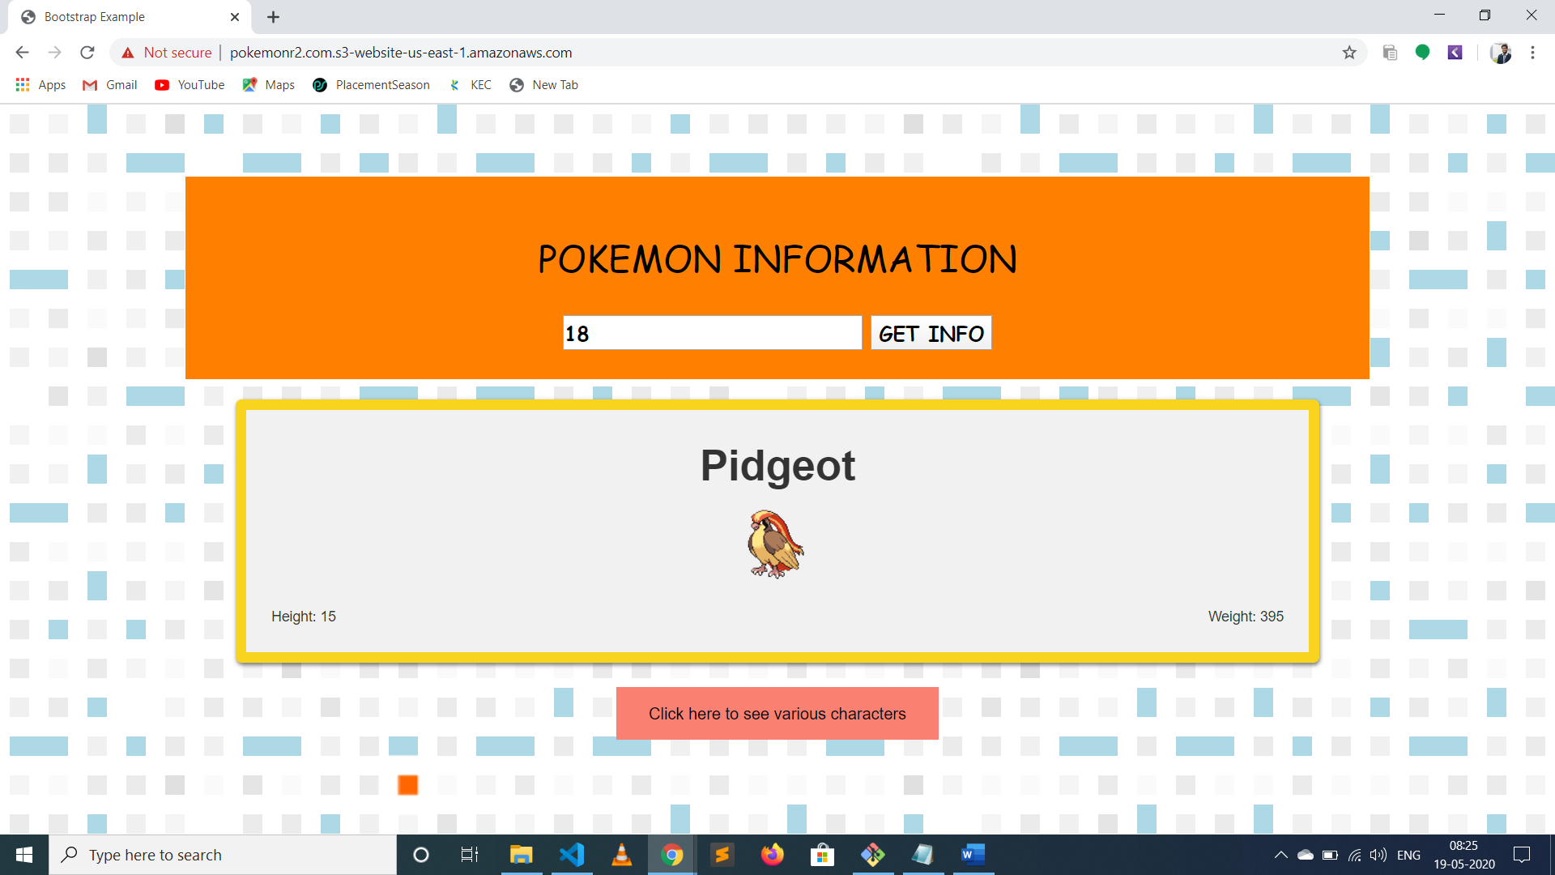

References:

<https://www.w3schools.com/>